June 27, 2024

Todd Schroeder Esquire

McKeen & Associates, P.C.

645 Griswold Street, Suite 4200

Detroit, Michigan 48226

Tel: (313) 961-4400

RE: *Norman Brown; Norman Norman et al. v Keith Rhymer, et al., Case No: 2:23-cv-02426, United States District Court for the Southern District of Ohio Eastern Division*

Date of Crash: July 19, 2021

Date of Birth: *Norman Brown:* April 1, 1958 [63 years old at time of crash]

*Norman Norman:* April 1, 1958 [63 years old at time of crash]

Dear Mr. Schroeder,

I am in receipt of your correspondence regarding the above-named action. I have reviewed the documentation accompanying your correspondence including medical records, information regarding the subject crash, litigation documents, and other materials.

The purpose of this report is to provide an analysis of the causal relationship between the subject rear impact collision and Mr. Brown and Mr. Norman’s subsequently diagnosed disk injuries and need for treatment.

*My qualifications to provide opinions concerning the matters herein, particularly on issues of the causal relationship between trauma and injury, are as follows:*

I am Professor and Chair of Forensic and Legal Medicine with the Faculty of Forensic and Legal Medicine of the Royal College of Physicians (UK), and a consultant in the fields of forensic medicine and forensic epidemiology. I am credentialed as a Fellow of the Royal College of Pathologists (UK), Fellow of the Faculty of Forensic and Legal Medicine (FFLM) of the Royal College of Physicians (UK) and member of the British Association in Forensic Medicine. I hold the following relevant academic degrees and certifications: a Doctor of Medicine degree (Med.Dr.) from Umeå University, a Doctor of Philosophy (Ph.D.) in public health/epidemiology from Oregon State University, a Master of Public Health (MPH) in epidemiology and biostatistics, also from Oregon State University, a master’s degree in forensic medical sciences (MScFMS) with the Academy of Forensic Medical Sciences in the United Kingdom, i.a. In addition to my degreed education, I have completed a 2-year post-doctoral fellowship in forensic pathology at Umeå University in Sweden and hold a Diploma of Legal Medicine (DLM) with the FFLM. I am also a fellow of both the American Academy of Forensic Sciences and the American College of Epidemiology. I am a Fulbright Fellow and held a 3-year roster appointment (2017-20) with the United States Department of State as a Fulbright Specialist in the field of forensic medicine. I serve as tenured Associate Professor of Forensic Medicine at Maastricht University and a joint Clinical Professor of Psychiatry and Public Health and Preventative Medicine at Oregon Health and Science University School of Medicine, where I have taught courses for the past 24 years in forensic medicine, forensic epidemiology, and injury epidemiology. From 2005-2017 I held an appointment as an Adjunct Professor of Forensic Medicine and Epidemiology at the Institute of Forensic Medicine, Faculty of Health Sciences, Aarhus University, Aarhus, Denmark, and am a recent (2020-21) visiting professor at University of Indonesia in the Faculty of Medicine.

I have been a crash reconstructionist since 1996 and have had ACTAR accreditation (the Accreditation Commission on Traffic Accident Reconstruction) since 2005. Over the past >25 years I have participated in the reconstruction of more than 3,000 crashes, including more than 300 fatalities. From 1999 through 2007 I served as a vehicular homicide investigator for law enforcement (consultant to the state medical examiner and special deputy sheriff), and I am a former affiliate medical examiner with the Allegheny County Medical Examiner’s office.

I am a member of the American Society of Biomechanics and have more than 60 scientific publications pertaining to injury biomechanics, including a book for the Society of Automotive Engineering and taught injury biomechanics in a faculty peer-reviewed course at OHSU for 15 years. I have served as a consultant on injury biomechanics to state and federal government.

I am an associate editor of the Journal of Forensic and Legal Medicine and serve or have served as an associate editor or editorial board member of 14 additional scientific peer-reviewed journals. I have published approximately 230 scientific papers, abstracts, book chapters and books on topics that include traffic crash injuries, crash reconstruction, injury causation and injury biomechanics, including the text for Elsevier, Forensic Epidemiology: Principles and Practice (2016). My publications have been cited by other authors more than 4,900 times.

I have provided testimony in more than 450 civil and criminal trials in state and Federal courts throughout the United States, Canada, and Australia. Please see my CV for further details.

*Post-crash history, Norman Brown (driver)*

*Post-crash history, Norman Norman (front passenger)*

**Documents Reviewed**

***Injury Causation Analysis***

A crash-related injury causation analysis for a specific individual is performed by assessing the risk of injury from the collision and comparing it to the probability that the injuries or conditions would have been present at the same point in time if the collision had not occurred. The process is referred to as a "3-step" injury causation method in which improbable alternative causes are ruled out and the single most likely cause is identified. The analysis is accomplished via the application of crash reconstruction, biomechanical, medical, and epidemiologic (risk assessment) principles.[1],[2] This 3-step methodology has been extensively described in the peer-reviewed literature, been deemed generally accepted by Courts in the United States, and has been adopted as part of case law in the U.S.[3],[4] See the Appendix at the end of this report for more information.

The three fundamental elements or steps of an injury causation analysis are as follows:

1. Whether the injury mechanism had the potential to cause the injury in question (aka general causation);

2. The degree of temporal proximity between the injury mechanism and the onset of the symptoms reasonably indicating the presence of the injury; and

3. Whether there is a more likely alternative explanation for the occurrence of the symptoms at the same point in time (aka differential etiology).

As applied to the facts in the subject case, these 3 steps are as follows:

*Injury mechanism: reconstruction of the crash, injury biomechanics*

*Reconstruction:*

*Analysis:*

*Injury biomechanics*

The rear impact would have resulted in Mr. Brown and Mr. Norman’s torsos and heads initially being thrown rearwards into the seatback at around 11 mph, and then rebounding forward into the restraining seat belt and toward the steering wheel (the first part of the crash kinematics that they ). they would have sustained substantial complex loads on their spines in the collision, loads that include compression, rotation, and shear all occurring at the same time and to varying degrees in less time than it takes to blink an eye (around 250 msecs).

The National Highway Traffic Safety Administration (NHTSA) has published injury risk curves for rear impact crashes, demonstrating a rate of minor or greater “MAIS 1+” (Maximum Abbreviated Injury Scale injury severity grade of 1 or more) injuries, nearly all requiring an emergency department visit, of 25% for a 11 mph delta V rear impact collision (see the blue arrow in the chart below). Approximately 94% of spinal disk injuries would be included in this category of injuries, as this is the rate at which disk injuries are initially diagnosed as strains (i.e., MAIS 1 [minor injuries]) in the emergency department in the first day or 2 after a crash, which is the source of the NHTSA data. There is also an approximately 1% chance of an immediately apparent more serious injury, including fracture, organ injury, or intracranial bleeding, etc. in a moderate speed rear impact crash of the same severity (see the red arrow in the chart below).

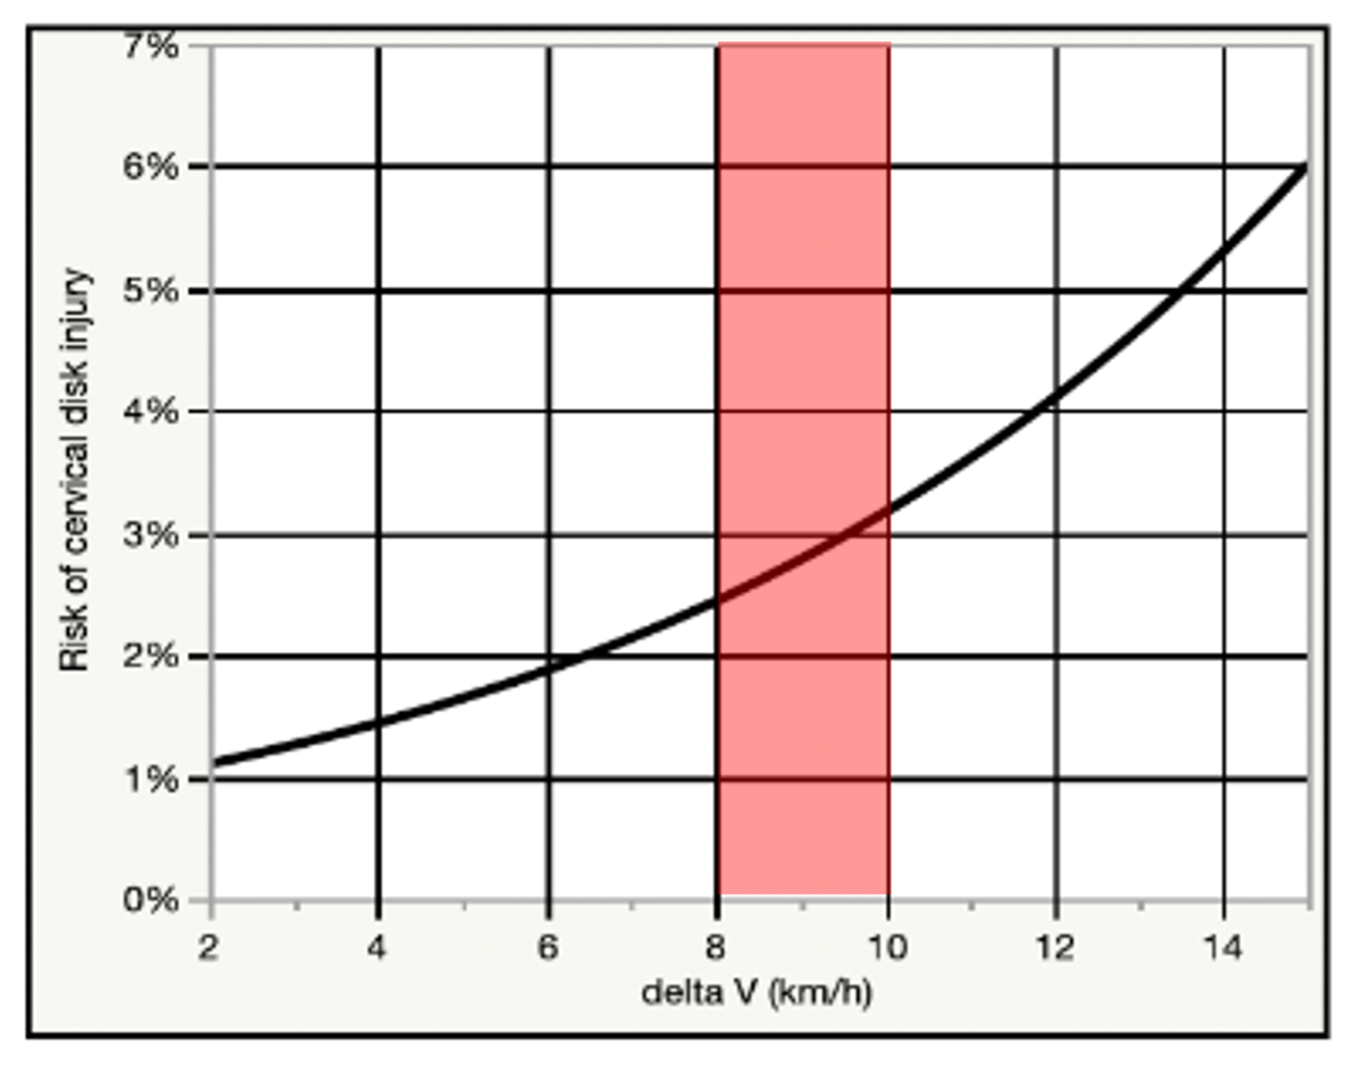

Chart showing the relationship between a ~5 to 6 mph delta V (red band) rear impact and cervical disk injury risk observed in 113 people exposed to real-world crashes. As demonstrated in the chart, the risk of a cervical disk injury ranges from 2.5 to 3.3%, or around 1 in 40 to 1 in 30 in such a crash. The risk to the low back is approximately 60% that of the risk to the neck. *Note:* 5 to 6 mph is approximately equal to 8 to 10 km/h on the chart.

Discussion

The types of spinal injuries that Mr. Brown and Mr. Norman were diagnosed with (primarily chronically symptomatic disk derangements) are highly consistent with the injury mechanism of the crash. Traumatic loading of the spine that results in axial (up and down) compression, particularly in combination with the other load types occurring with the subject collision, has the potential to damage the peripheral disk annulus, which surrounds and holds in the disk nucleus. Men in their early 7th decade, like Mr. Brown (who was 63 at the time of the crash) typically have moderate to advanced age-related degenerative changes of the disks of the spine, a fact that makes the post-crash findings in Mr. Brown and Mr. Norman’s imaging reasonably a combination of post-traumatic overlaying degeneration, as opposed to solely due to either trauma or pre-existing degeneration.

The symptoms of spinal disk injury may, in some cases, be instantly recognizable after a traffic crash because of the sudden onset of radiculopathy, but recent research has demonstrated that only about 1 in 17 cervical disk injuries are recognized as such in the ED after a crash.[5] By far, the majority (94%) of what are later determined to be spinal disk injuries are initially diagnosed as in the ED as spinal strains.

Although the subject crash was no "bumper tap" it is well established in science and medicine that an excessive level of force is not required to cause symptomatic injury to a degenerated disk, and that in most cases, the diagnostic imaging of the disk will not reveal whether related symptoms are of a traumatic origin or not, in the absence of fracture.[6] Traumatic disk injuries have been described in the peer-reviewed literature as resulting from low to moderate force events, including minimal or no damage traffic crashes, roller coaster rides, and even more mild forces such as sneezing.[7]-[8][9][10][11][12][13] It is accurate to state that there is no established or generally accepted lower force threshold at which it can be said that an acute intervertebral disk injury in any part of the spine cannot occur.

Based on the preceding discussion there was ample and biomechanically appropriate force exerted on Mr. Brown and Mr. Norman’s bodies in the subject collision to have caused their medically documented injuries, and associated need for evaluation and treatment, including their spinal pain management procedures, etc.

**Temporal relationship between the crash and symptoms indicative of injury**

The second step of the injury causation analysis is the assessment of the timing between the trauma and the onset of symptoms indicative of injury. The hallmark of injury is that "you know it when it happens;" *i.e.* the causal relationship between the trauma and onset of the symptoms indicative of the injury is usually close enough in time that it is easy to recognize when the injury was incurred. There are some injuries that exhibit a delayed onset of symptoms, including injuries to intervertebral disks, which can first manifest with identical symptoms to a simple spinal strain. Other injuries are always immediately apparent, such as bony fractures. Some injuries are considered "distracting" from others because the pain they generate distracts attention from other, less painful injuries. There are still other injuries that can "mask" pain from nearby parts of the body through complicated pain accommodation mechanisms that are mediated at the spinal cord and in the brain. The assessment of the timing of the onset of symptoms reasonably attributed to an injury can sometimes be nuanced and complicated, and sometimes requires expert assessment.

Mr. Brown experienced the onset of symptoms indicative of acute spinal injury immediately after the crash, and they were diagnosed with neck and back injuries directly by 3 days following the crash, including the presentation of lower extremity radicular symptoms, an ominous early sign of injury to the intervertebral disks in the spine. The symptoms and diagnoses progressively evolved and worsened over the weeks and months following the crash and demonstrate a well-documented contiguous chain of causation linking the subject crash and Mr. Brown and Mr. Norman's diagnosed low back and cervical spinal injuries, and associated need for treatment.

Based on this history, there was a strong temporal relationship between the subject collision and Mr. Brown and Mr. Norman’s first development of symptoms indicative of spinal injury.

**Alternative explanations**

This last step of the injury causation analysis specific to the individual involves the assessment of the probability of the same symptoms, injuries, diagnoses, and need for treatment occurring at the same point in time, but in the absence of the investigated crash.

This part of the analysis is accomplished in 2 ways; first and most obviously, any competing contemporaneous traumatic cause of injury must be ruled out. There is, however, no such history for Mr. Brown or Mr. Norman, and the only source of trauma apparent in my review of materials that is temporally proximate to their post-crash injuries is the July 19, 2021, moderate speed rear impact crash.

The second part of the analysis requires an assessment of the probability that Mr. Brown or Mr. Norman would have developed the symptoms and diagnoses of spine injury at the same point in time had they not been initially injured in the July 19, 2021, rear impact crash. As a generally healthy 63-year-old male, Mr. Brown and Mr. Norman was at a negligible annual risk of spontaneously developing chronically painful and potentially surgical cervical or lumbar spinal disk derangements; less than 1 in 2,000 is indicated by epidemiologic study and national hospital data.[14] The chance that theywere going to develop the onset of chronic neck or low back pain attributable to symptomatic disk derangements on the same day as the crash by pure coincidence is obviously much smaller; less than 1 in 730,000 (the annual risk divided by 365 days). In comparison the risk of any acute spine injury in the subject crash was likely more than 50%, and the risk of a spinal disk injury was likely no less than 1 in 25 in the general population.[15] Based on this comparison of risk during the timeframe of interest, the crash is the most likely cause of Mr. Brown and Mr. Norman’s chronic spinal injuries by >99%.The second part of the analysis requires an assessment of the probability that Mr. Brown or Mr. Norman would have developed the symptoms and diagnoses of spine injury at the same point in time had they not been initially injured in the July 19, 2021, rear impact crash. As a generally healthy 63-year-old male, Mr. Brown and Mr. Norman was at a negligible annual risk of spontaneously developing chronically painful and potentially surgical cervical or lumbar spinal disk derangements; less than 1 in 2,000 is indicated by epidemiologic study and national hospital data.[16] The chance that theywere going to develop the onset of chronic neck or low back pain attributable to symptomatic disk derangements on the same day as the crash by pure coincidence is obviously much smaller; less than 1 in 730,000 (the annual risk divided by 365 days). In comparison the risk of any acute spine injury in the subject crash was likely more than 50%, and the risk of a spinal disk injury was likely no less than 1 in 25 in the general population.[17] Based on this comparison of risk during the timeframe of interest, the crash is the most likely cause of Mr. Brown and Mr. Norman’s chronic spinal injuries by >99%.

A relatively common medicolegal question is whether persisting symptoms of back or neck pain after a traffic crash are truly related to the crash, or more probably due to other factors incidental to an acute crash-related injury to the spine. Most typically, the "other factors" that are raised in a medicolegal setting are the presence of pre-existing degenerative changes in the spine, or pre-crash history of low level or sporadic symptoms.

The answer to this question is now decided science. Along with my research colleagues, I have recently published 2 analyses and systematic reviews of nearly 10,000 articles regarding the long-term effects of traffic crash-related injury to the neck and low back and associated chronic pain.[18],[19] Systematic reviews are considered the most reliable and strongest form of scientific evidence (i.e. Level I evidence), as they consist of a comprehensive synthesis of world literature on a topic.[20] The result of the analyses indicate that when men like Mr. Brown and Mr. Norman have persisting neck or back pain after an acute crash-related injury, *more often than not* (>50% of the time) the symptoms are due to the crash, versus all other causes, regardless of pre-crash medical history.

Conclusions<w:rPr><w:rFonts/><w:b w:val="true"/><w:u w:val="single"/></w:rPr>

Given the contiguous chain of causation from the day of the crash through Mr. Brown and Mr. Norman’s most recent medical records, the lack of any significant pre-crash history of persisting spine pain and need for treatment in the years prior to the crash, as well as the relative risk of significant and persisting spine injury from the subject rear impact crash, I conclude that the most probable cause of the post-crash acute and chronic neck and low back injuries described in Mr. Brown and Mr. Norman’s medical records and summarized in this report, including their symptomatic cervical and lumbar disk derangements, is the subject July 19, 2021, moderate speed rear impact crash.

I have examined neither Mr. Brown nor Mr. Norman and I therefore have no opinions about their diagnoses, treatment, or prognoses outside of what is reflected in the medical record.

The preceding opinions were given as reasonable medical, and scientific probabilities. I reserve the right to amend any of my opinions should new information come to light.

Very truly yours,

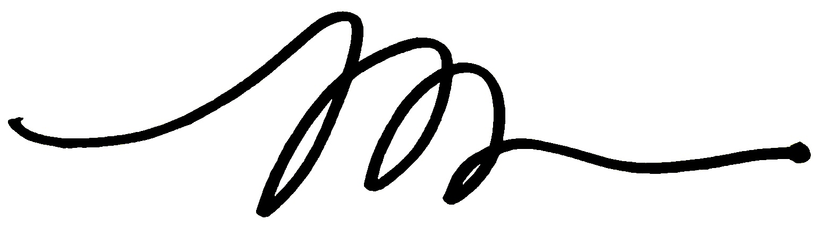

Michael D. Freeman, MedDr, PhD, MScFMS, MPH, FRCPath, FFFLM, FACE, DLM

**David Jenkins Memorial Professor and Chair in Forensic and Legal Medicine**  
Faculty of Forensic and Legal Medicine, Royal College of Physicians (London, UK)  
  
**Associate Professor of Forensic Medicine,**  
Care and Primary Healthcare Research Institute, Faculty of Health, Medicine, and Life Sciences, Maastricht University, Maastricht, Netherlands  
  
**Clinical Professor of Forensic Psychiatry**  
Department of Psychiatry, School of Medicine, Oregon Health & Science University  
  
Fellow, Royal College of Pathologists (UK)  
Fellow, Faculty of Forensic and Legal Medicine, Royal College of Physicians (London, UK)  
Fellow, American College of Epidemiology  
Member, American Society of Biomechanics

**Appendix**

The 3-step causation methodology that I have used in this case is set forth in a number of my peer-reviewed publications, including a paper entitled *A Systematic Approach to Clinical Determinations of Causation in Symptomatic Spinal Disk Injury Following Motor Vehicle Crash Trauma*, published in the Journal of Physical Medicine & Rehabilitation in 2009. I first described this 3-step methodology in a paper published in 2008 and have since published more than a dozen papers describing some of the manifold applications of the causation methodology. As I describe below, the 3-step causal methodology has recently become part of United States Appellate Court case law on injury causation.

The methodology set forth in my 2009 paper consists of 3 steps or elements that need to be satisfied in an injury causation analysis in order to conclude that an injury resulted from a particular event to a reasonable degree of medical/scientific probability, which are as follows:

1. Plausibility: This first step addresses whether it is biologically *possible* for the injury event to have caused the condition (a.k.a general causation). A finding of plausibility is unrelated to the *frequency* of the injury, because even if the injury occurs in only 1 in 100 or fewer cases of exposure to the event (e.g. a spinal disk injury following a car crash), it is still *plausibly* caused by the event. Plausibility is a relatively low hurdle to clear in a causal analysis and is largely satisfied by the lack of evidence of *implausibility* of the relationship. Although it is common in crash injury litigation for the defendant to assert minimal vehicle damage as a basis for disputing injury causation, the approach is unhelpful for evaluating plausibility, as such an analysis does not have a sufficiently low error rate to establish impossibility, and at best can only be used to suggest a low frequency of injury in the general population. An example of an *impossible* causal relationship is the discovery of leukemia the day after a crash, as it is well established that it is not biologically plausible for trauma to cause leukemia. Plausibility is often, but not necessarily, established with epidemiologic data or information.

2. Temporality: This second step examines the clinical and other evidence of the timing between the onset of the symptoms of injury and the injury event and must be satisfied to assess specific causation. First, it must be established that the sequence of the injury and the event is appropriate; the symptoms cannot be identically present prior to the event. Further, the onset of the symptoms of injury cannot be implausibly latent, relative to the injury event. For example, while the symptoms of a spinal disk injury in the neck may not immediately include upper extremity radiculopathy (most such injuries are initially diagnosed as a simple sprain or strain), a complete absence of symptoms in the neck for 3 months after a traffic crash, followed by the sudden insidious onset of symptoms of a cervical disk injury with radiculopathy, could not be plausibly related to the crash in most cases.

3. Lack of a more probable alternative explanation: This final step examines the probability of the injury condition occurring at the same point in time in the plaintiff, given what is known about the plaintiff from the review of medical records and other evidence, but in the absence of the injury event (a.k.a. differential etiology). First, evidence of competing injury events must be evaluated, and compared for injury risk. Then, the likelihood of the condition occurring spontaneously must be assessed. For example, the plaintiff may have evidence of degenerative changes in the spinal disks pre-existing a traffic crash, but no symptoms. The question of interest (after the first 2 steps are satisfied) is what the probability was that the condition would have "converted" from asymptomatic to symptomatic in the absence of ("but-for") the crash. Since there is no information that can be gleaned from an examination of the plaintiff regarding her or her condition in the hypothetical absence of the crash, epidemiologic data often serves as the basis for the evaluation of the probability of alternative explanations. More probable alternative explanations are often intervening traumatic events that alter the clinical history in a substantive way. As an example, for a plaintiff with neck strain symptoms that lasted for 1 week after a crash, who is then involved in second collision a month later that results in neck and arm pain and is ultimately diagnosed with a cervical disk herniation, the second collision is easily identified as a more probable cause of the disk derangement than the antecedent crash. This is in part due to the abrupt change in the distribution of the symptoms more consistent with a disk derangement, but also the epidemiologically based conclusion that it is rare for a cervical strain that improves rapidly to evolve into a cervical disk herniation, and thus but-for the second crash, the condition would not have manifested.

The methodology described above was used to evaluate the cause of the Plaintiff’s injury in Etherton v Owners Insurance Company, entered on March 3, 2014 in United States District Court for the District of Colorado. In Etherton, the Plaintiff’s medical expert relied on the above referenced article to support her methodology (see footnote 3 on page 8 of the decision). The expert specified the same 3-step approach to assessing causation outlined above, described by the Court on page 8 of the order as follows:

"…his first step was to determine general causation… whether or not the type of injury that the plaintiff sustained could have been caused by the type of collision that the plaintiff was in… her second step was to consider whether there was a temporal relationship between plaintiff’s injury and the collision… her third step was to… rule out alternative causes of plaintiff’s injury."

The defense challenged, among other things, the reliability and fit of the methods described by the expert. After an extensive examination and discussion of the 3-step process used by the expert, the Court found that the methodology appropriately fit the specific facts of the case, and that a population-based (epidemiologic) approach was an appropriate part of the causal methodology. The Court denied the Defendant’s motion to strike the expert’s testimony.

The Defendant appealed the ruling from the District Court, and in July of 2016, the Tenth Circuit U.S. Court of Appeals unanimously affirmed the 3-step causal methodology described in my 2009 publication cited above as generally accepted and well established for assessing injury causation (see *Etherton v. Owners Insurance Company*, No. 14-1164, 10th Cir, entered on July 19, 2016). Using the 3-step methodology, the Court determined the expert’s methodology fit the specific facts in the case, and that the District Court properly applied Rule 702/Daubert standard to the expert’s testimony in finding his methodology reliable. The judicial panel included current Supreme Court Justice Neil Gorsuch.

Below is a partial list of publications in scientific journals in which my descriptions of the 3-step methodology described in the *Etherton* decision and its various applications have been subjected to peer review. The foundation for the specific causation methodology described in all of these papers is the "Hill criteria," a guideline for the assessment of general causation that has been universally relied on in medicine and science for more than 50 years.

Dianita Ika Melia P, Zeegers MP, Herkutanto H, Freeman MD. Medicolegal causation investigation of bacterial endocarditis associated with an oral surgery practice using the INFERENCE approach. *Int J Environ Res Public Health* 2021:18,7530. https://doi.org/10.3390/ijerph18147530.

Dianita Ika Melia P, Zeeger MP, Herkutanto H, Freeman MD. Development of the INFERENCE (INtegration of Forensic Epidemiology and the Rigorous EvaluatioN of Causation Elements) approach to causal inference in forensic medicine. *Int J Environ Res Public Health* 2020;17:8353; doi:10.3390/ijerph17228353

Dianita Ika Melia P, Freeman MD, Herkutanto H, Zeeger MP. A review of causal inference in forensic medicine. *For Sci Med Path* 2020:doi.org/10.1007/s12024-020-00220-9.

Freeman MD. A practicable and systematic approach to medicolegal causation. *Orthopedics* 2018;41(2):70-2.

Freeman MD, Zeegers M. Principles and applications of forensic epidemiology in the medicolegal setting. *Law, Probability, & Risk* 2015; doi:10.1093/lpr/mgv010.

Freeman MD. Medicolegal causation analysis of a lumbar spine fracture following a low speed rear impact traffic crash. *J Case Rep Prac* 2015; 3(2): 23-29.

Freeman MD, Cahn PJ, Franklin FA. Applied forensic epidemiology. Part 1: medical negligence. *OA Epidemiology* 2014;2(1):2.

Koehler S, Freeman MD. Forensic epidemiology; a methodology for investigating and quantifying specific causation. *Forens Sci Med Path* 2014 Jun;10(2):217-22.

Freeman MD, Kohles SS. An examination of the threshold criteria for the evaluation of specific causation of mesothelioma following a history of significant exposure to chrysotile asbestos-containing brake dust, *Int J Occ Env Hlth* 2012;18(4):329-36.

Freeman MD, Everson T, Kohles SS. Forensic epidemiologic and biomechanical analysis of a pelvic cavity blowout injury associated with ejection from a personal watercraft (jet-ski). *J Forens Sci* 2012 doi: 10.1111/j.1556-4029.2012.02250.x

Freeman MD, Kohles SS. Plasma levels of polychlorinated biphenyls, non-Hodgkin lymphoma, and causation. *J Environ Public Health* 2012;2012:258981. doi: 10.1155/2012/258981. Review.

Freeman MD, Kohles SS. Application of the Hill Criteria to the Causal Association of Post-Traumatic Headache and Assault. *Egypt J Forensic Sci* 2011;1:35-40.

Freeman MD, Kohles SS. Application of the Bradford-Hill Criteria for Assessing Specific Causation in Post-Traumatic Headache. *Brain Inj Prof* 2011;8(1):26-8.

Freeman MD, Kohles SS. An Evaluation of Applied Biomechanics as an adjunct to systematic specific causation in forensic medicine. *Wien Med Wochenschr* 2011;161:1-11.

Freeman MD, Centeno CJ, Kohles SS. A systematic approach to clinical determinations of causation in symptomatic spinal disc injury following motor vehicle crash trauma. *PM R* 2009;1(10):951-6.

Freeman MD, Rossignol AC, Hand M. Forensic Epidemiology: A systematic approach to probabilistic determinations in disputed matters. *J Forensic Legal Med* 2008;15(5):281-90.

1. Melia P et al. Development of the INFERENCE (INtegration of Forensic Epidemiology and the Rigorous EvaluatioN of Causation Elements) approach to causal inference in forensic medicine. Int J Environ Res Public Health 2020;17:8353; doi:10.3390/ijerph17228353.
2. Freeman MD. A practicable and systematic approach to medicolegal causation. Orthopedics 2018;41(2):70-2.
3. Freeman MD, Centeno CJ, Kohles SS. A systematic approach to clinical determinations of causation in symptomatic spinal disc injury following motor vehicle crash trauma. PM R 2009;1(10):951-6.
4. Etherton v. Owner Insurance Company. U.S. District Court of Appeals, 10th Circuit. Case No. 14-1164.
5. Freeman MD, Leith WM. Estimating the number of traffic crash-related cervical spine injuries in the United States; an analysis and comparison of national crash and hospital data. Accident Analysis and Prevention 2020: doi:https://doi.org/10.1016/j.aap.2020.105571.
6. Fardon et al. Lumbar disc nomenclature: version 2.0: Recommendations of the combined task forces of the North American Spine Society, the American Society of Spine Radiology and the American Society of Neuroradiology. Spine J. 2014;14(11):2525-45.
7. Giuliano et al. The use of flexion and extension MR in the evaluation of cervical spine trauma: initial experience in 100 trauma patients compared with 100 normal subjects. Emerg Radiol. 2002;9(5):249-53.
8. Freeman et al. Significant spinal injury resulting from low-level accelerations: A case series of roller coaster injuries. Arch Phys Med Rehab 2005;86:2126-30.
9. Lutz et al. CT myelography of a fragment of a lumbar disk sequestered posterior to the thecal sac. Am J Neuroradiol 1990;11(3):610-1.
10. Sadanand et al. Sudden quadriplegia after acute cervical disc herniation. Can J Neurol Sci 2005;32(3):356-8.
11. Pappas et al. Outcome analysis in 654 surgically treated lumbar disc herniations. Neurosurgery 1992;30(6):862–6.
12. Smith J. An analysis of 72 real world impacts - an initial investigation into injury and complaint factors. SAE Technical Paper 1999-01-0640.
13. Freeman MD. Medicolegal causation analysis of a lumbar spine fracture following a low speed rear impact traffic crash. J Case Rep Prac 2015; 3(2): 23-9.
14. Nationwide Inpatient Sample, Healthcare Utilization Project, Agency for Health Research and Quality, US Department of Health and Human Resources
15. Nolet et al. Is acceleration a valid proxy for injury risk in minimal damage traffic crashes? A comparative review of volunteer, ADL and real-world studies. Environ Res Public Health 2021;18:2901; https://doi.org/10.3390/ijerph18062901.
16. Nationwide Inpatient Sample, Healthcare Utilization Project, Agency for Health Research and Quality, US Department of Health and Human Resources
17. Nolet et al. Is acceleration a valid proxy for injury risk in minimal damage traffic crashes? A comparative review of volunteer, ADL and real-world studies. Environ Res Public Health 2021;18:2901; https://doi.org/10.3390/ijerph18062901.
18. Nolet et al. Exposure to a Motor Vehicle Collision and the Risk of Future Neck Pain: A Systematic Review and Meta-Analysis. PM R. 2019 Apr 25. doi: 10.1002/pmrj.12173.
19. Nolet et al. Exposure to a motor vehicle collision and the risk of future back pain: A systematic review and meta-analysis. Accid Analysis Prev 2020: https://doi.org/10.1016/j.aap.2020.105546
20. https://libguides.winona.edu/c.php?g=11614&p=61584